REGISTRATION FORM FOR PARTICIPATION
ORGANIC TABLE 2026
IX International Fair of Organic and Traditional Products
AGROMAK 2026
V International Fair of Agriculture, Technologies, Food and Processing
02-04 October 2026, Sports and Recreation Centre - Kumanovo, area in front of the City Swimming Pool
Organizers: Association for Development of Agriculture and Environmental Protection "ZIVOT" - Kumanovo and Chamber of Organic Producers of Macedonia - KOP
Instruction: This form may be completed directly in Word, then signed, stamped and submitted scanned/signed by e-mail to the Organizer.

1. DATA OF THE EXHIBITOR / PARTICIPANT / APPLICANT
Name of exhibitor: | Click/type here | Authorized representative: | Click/type here
Address: | Click/type here | Tax No. / VAT No.: | Click/type here
City / place: | Click/type here | Company registration No.: | Click/type here
Country: | Click/type here | Bank account: | Click/type here
Postal code: | Click/type here | Bank: | Click/type here
Contact phone: | Click/type here | E-mail: | Click/type here
Fair contact person: | Click/type here | Phone: | Click/type here

2. SELECTION OF EXHIBITION SPACE AND EQUIPMENT
Prices are stated in Macedonian denars excluding VAT. The Organizer may, by special written invitation/confirmation, approve free basic exhibition space for the first 100 duly registered participants, subject to available capacities. This benefit does not include additional equipment, additional services, advertising, special technical requirements or sponsorship/partnership packages, unless otherwise stated in a written confirmation by the Organizer.

2.1. RENTAL OF OUTDOOR EXHIBITION SPACE - TENT
☐ I order a fully equipped exhibition space - TENT |  |  | 6,550.00 MKD + VAT
Quantity: |  | Dimensions / description: | tent 3 x 3 m (9 m²)
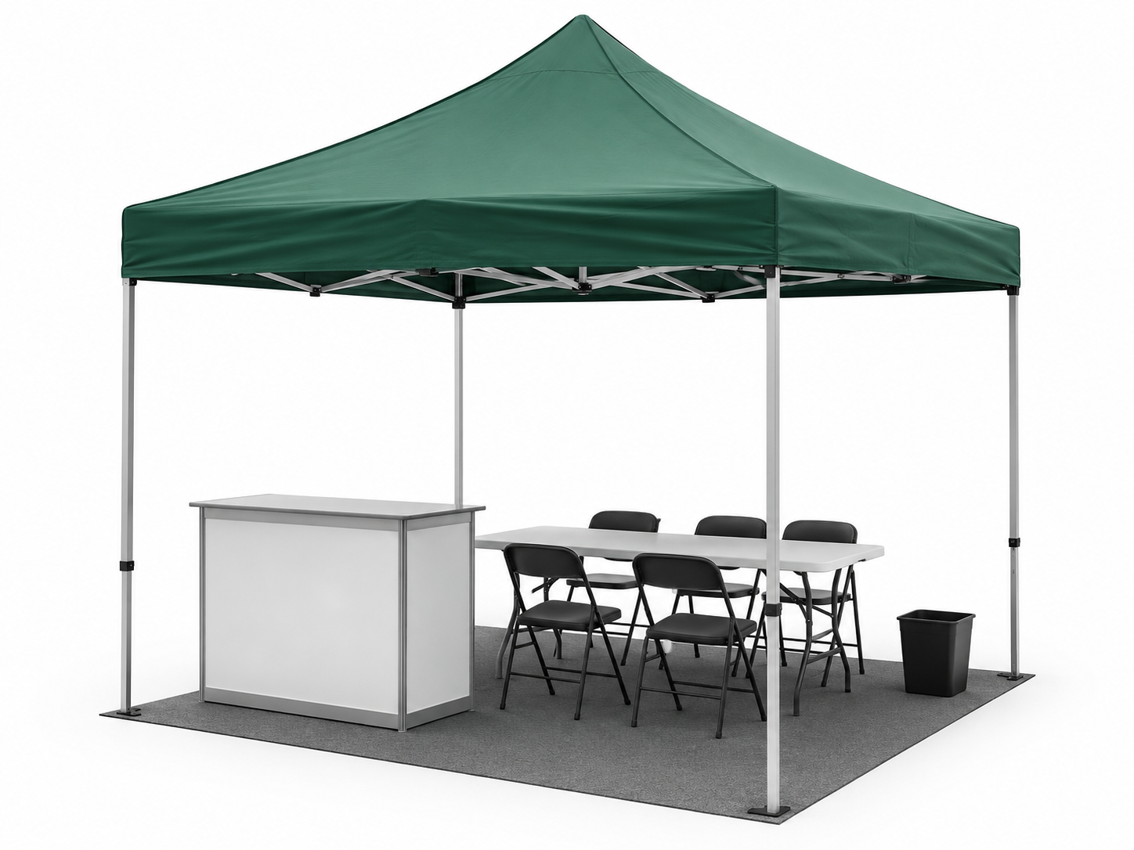 |  | The fully equipped space includes: 3 x 3 m tent (9 m²), information counter, chair and waste bin. The arrangement of the equipment is determined by the Organizer according to the technical possibilities of the fair area.

☐ I order an unequipped exhibition space - TENT |  |  | 5,550.00 MKD + VAT
Quantity: |  | Dimensions / description: | tent 3 x 3 m (9 m²)
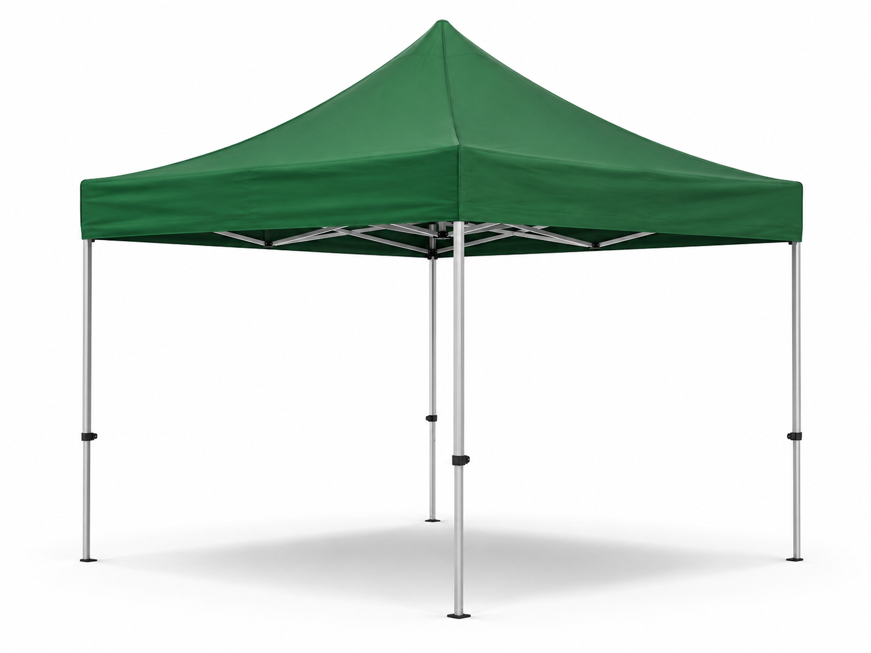 |  | The unequipped space includes a mounted tent without additional fair equipment. The exhibitor may order additional equipment according to the price list or use own equipment with prior approval from the Organizer.

2.2. RENTAL OF OUTDOOR EXHIBITION SPACE - PAGODA
☐ I order a fully equipped exhibition space - PAGODA |  |  | 31,491.00 MKD + VAT
Quantity: |  | Dimensions / description: | pagoda 6.1 x 6.1 m (37.2 m²)
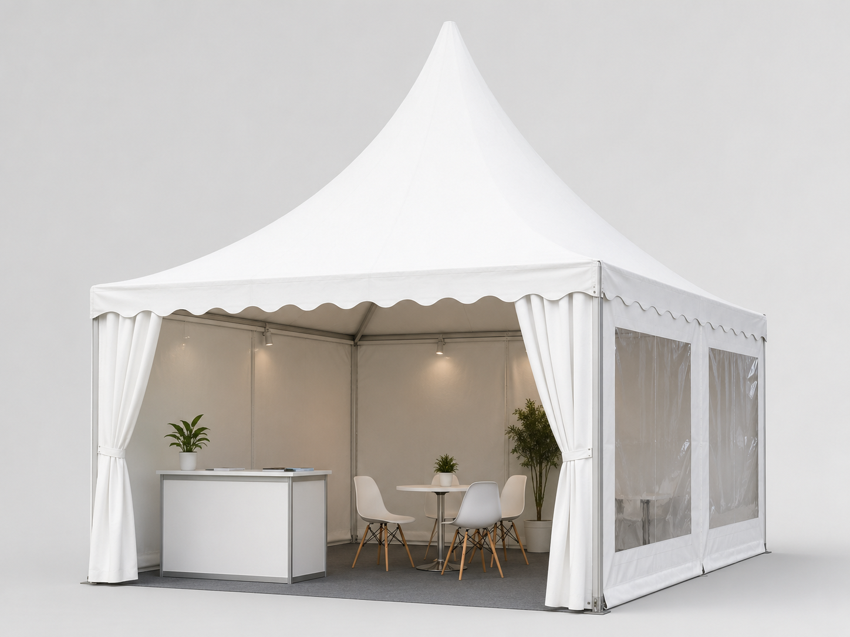 |  | The fully equipped space includes: pagoda with side walls and transparent foil windows, floor covering, information counter, chair, table with 4 chairs, 220V electrical connection up to 1 kW and waste bin.

☐ I order an unequipped exhibition space - PAGODA |  |  | 27,491.00 MKD + VAT
Quantity: |  | Dimensions / description: | pagoda 6.1 x 6.1 m (37.2 m²)
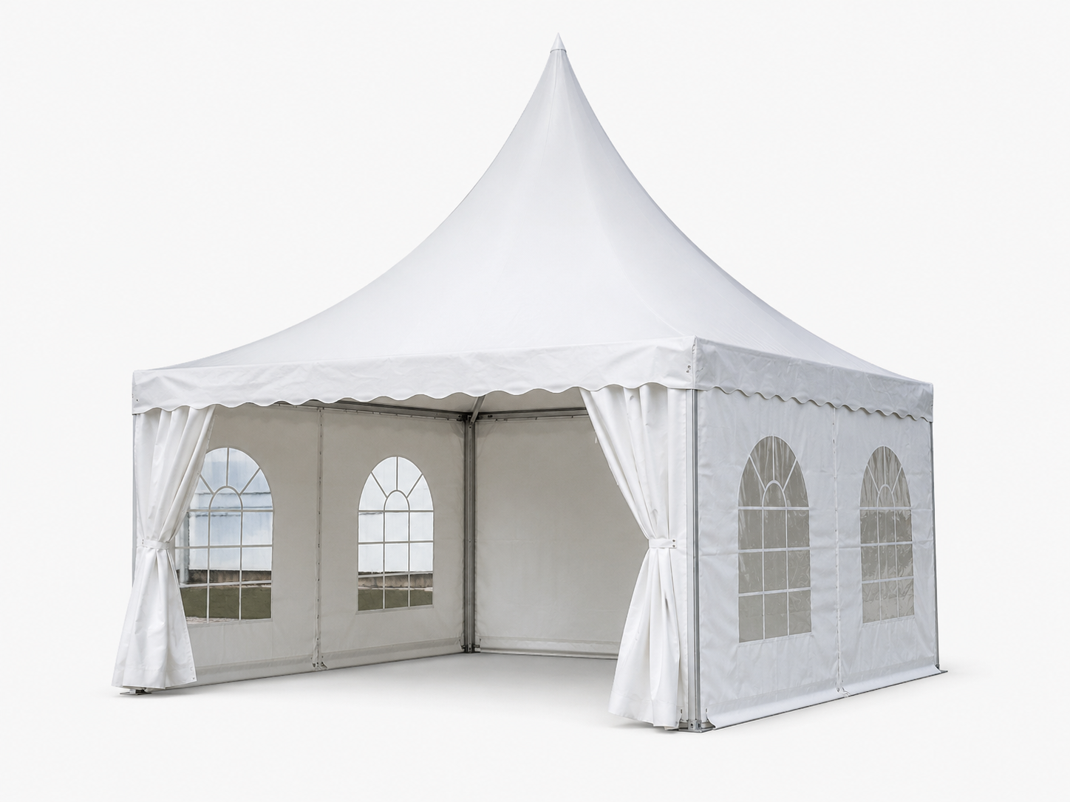 |  | The unequipped space includes a mounted pagoda with side walls and transparent foil windows, without additional fair equipment. The exhibitor may order additional equipment according to the price list.

3. OUTDOOR UNFENCED EXHIBITION SPACE FOR MACHINERY, TOOLS AND VEHICLES
☐ I order m² | Space size | Price | Note / quantity
 | up to 200 m² | 308.00 MKD/m² + VAT
 | from 201 m² to 300 m² | 278.00 MKD/m² + VAT
 | from 301 m² to 500 m² | 265.00 MKD/m² + VAT
 | over 501 m² | 250.00 MKD/m² + VAT

4. PARTNERSHIP / SPONSORSHIP PACKAGES
☐ CO-ORGANIZER PARTNER | ☐ SILVER SPONSOR PARTNER
☐ COCKTAIL SPONSOR PARTNER | ☐ GOLD SPONSOR PARTNER
☐ BRONZE SPONSOR PARTNER | ☐ GENERAL SPONSOR

5. ADDITIONAL SERVICES
Selection | Description | Price | Quantity / note
☐ | Distribution of promotional material by mascots | 3,000.00 MKD
☐ | Vertical facade banner 3.2 m x 7.5 m | 18,000.00 MKD

6. PRICE LIST FOR ADDITIONAL FAIR EQUIPMENT
No. | Item | Dimensions | Price | Quantity
1. | Chair |  | 370.00 MKD
2. | Table | 80 x 180 | 1,950.00 MKD
3. | School bench | 80 x 120 | 500.00 MKD
4. | Information counter | 40 x 80 | 1,000.00 MKD
5. | Bar stool |  | 1,250.00 MKD
6. | Bar table / standing table |  | 1,250.00 MKD
7. | Refrigerator |  | by agreement
Please attach your logo in PDF format to the e-mail, if you request promotional visibility or participate in a partnership/sponsorship package.

7. GENERAL TERMS AND CONDITIONS OF PARTICIPATION
Article 1 - These General Terms and Conditions regulate the relations between the exhibitor/participant/applicant and the organizers: Association for Development of Agriculture and Environmental Protection "ZIVOT" - Kumanovo and Chamber of Organic Producers of Macedonia - KOP, regarding participation in ORGANIC TABLE 2026 and AGROMAK 2026.
Article 2 - The Participant applies for participation by completing this Registration Form. By completing, signing and stamping the Registration Form, the Participant confirms acceptance of the terms stated in this form, the price list and any additional instructions provided by the Organizer.
Article 3 - The Registration Form shall be completed electronically or legibly in block letters, signed and stamped, and then submitted to the Organizer by e-mail. The deadline for submission of applications is 20.09.2026, unless the Organizer determines another deadline in writing.
Article 4 - The Organizer reserves the right not to accept an application if the fair capacities are filled, if the application is incomplete, if the Participant has unsettled obligations towards the Organizer, or if the nature of the products/activity is not appropriate to the concept of the event.
Article 5 - Upon receipt of a duly completed Registration Form, the Organizer shall issue an application confirmation and/or invoice, according to the selected services. The Participant undertakes to pay the invoiced amount within the deadline stated on the invoice, unless free basic exhibition space has been approved by a special written confirmation from the Organizer.
Article 6 - The promotional opportunity for free basic exhibition space for the first 100 duly registered participants applies exclusively on the basis of a written invitation or written confirmation from the Organizer. The Organizer independently determines the type and layout of the free basic space, according to available capacities and the programme layout.
Article 7 - Exhibition space means the space allocated to the Participant by the Organizer in accordance with the application, available capacities and the technical layout of the fair. The Participant may not transfer or sublease the space to third parties without prior written approval from the Organizer.
Article 8 - The Participant is obliged to arrange and equip the exhibition space no later than one day before the beginning of the fair, in accordance with the Organizer’s instructions. Delivery, assembly, dismantling and positioning shall be carried out according to technical instructions and a schedule provided by the Organizer.
Article 9 - The Participant is responsible for its products, equipment, promotional materials, vehicles and engaged persons. The Participant undertakes to comply with safety regulations, fire protection, hygiene, public order and the conditions of the fair area.
Article 10 - Early dismantling and leaving the exhibition space before the official closing of the fair is not allowed without prior approval from the Organizer. In case of breach of this provision, the Organizer may charge a contractual penalty in the amount of EUR 500 in Macedonian denar equivalent with VAT.
Article 11 - In case of cancellation of participation, the Participant must notify the Organizer in writing. For cancellation no later than 15 days before the opening of the fair, the Participant shall compensate 50% of the value of the ordered services. For cancellation less than 15 days before the opening of the fair, the Participant shall compensate 100% of the value of the ordered services.
Article 12 - The Organizer shall not be liable for damages caused by force majeure, weather conditions, power outage, decisions of competent authorities, theft, damage or other circumstances beyond its control. The Participant may independently arrange insurance for its products and equipment.
Article 13 - All complaints shall be submitted in writing to the Organizer as soon as possible. For any disputes that cannot be resolved amicably, the competent court shall be the Basic Court in Kumanovo, Republic of North Macedonia.
Article 14 - This Registration Form, signed and stamped by the Participant and accepted by the Organizer, has the legal force of an order/contractual basis for the rental or use of exhibition space and ordered fair services.

8. SIGNATURE AND STAMP
For the exhibitor / participant / applicant | For the Organizer
Name, surname and function: | Name, surname and function:
Signature: | Signature:
Stamp: | Stamp:
Place and date: | Place and date:
Contact for submitting applications: E-mail: zdruzenie.zivot@gmail.com | Phone: +389 70 88 88 17

